Solution
A solution is a homogeneous mixture of two or more substances on molecular level. The constituent of the mixture present in a smaller amount is called the Solute and the one present in a larger amount is called the Solvent. For example, when a smaller amount of sugar (solute) is mixed with water (solvent), a homogeneous solution in water is obtained. In this solution, sugar molecules are uniformly dispersed in molecules of water.

TYPES OF SOLUTIONS:

There are seven types of solutions whose examples are listed in Table
CONCENTRATION OF A SOLUTION

The concentration of a solution is defined as : the amount of solute present in a given amount of solution.

Concentration = Quantity of solute
Volume of solution
There are several ways of expressing concentration of a solution :
(a) Per cent by weight
(b) Mole fraction
(c) Molarity
(d) Molality
(e) Normality
Per cent by Weight
It is the weight of the solute as a percent of the total weight of the solution. That is,

MOLE FRACTION

Mole fraction, X, of solute is defined as the ratio of the number of moles of solute and the total number of moles of solute and solvent.

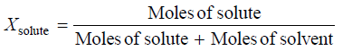

MOLARITY
Molarity (symbol M) is defined as the number of moles of solute per litre of solution. If n is the number of moles of solute and V litres the volume of solution.

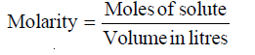

MOLALITY
Molality of a solution (symbol m) is defined as the number of moles of solute per kilogram of solvent :
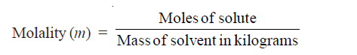
A solution obtained by dissolving one mole of the solute in 1000 g of solvent is called one molal or 1m solution.
Molality is defined in terms of mass of solvent while molarity is defined in terms of volume of solution.

NORMALITY
Normality of a solution (symbol N) is defined as number of equivalents of solute per litre of the
solution :
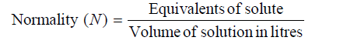
Thus, if 40 g of NaOH (eq. wt. = 40) be dissolved in one litre of solution, normality of the solution is one and the solution is called 1N (one-normal). A solution containing 4.0 g of NaOH is 1/10 N or 0.1 N or decinormal.

(vi) Formality
It is the number of formula weight in grams dissolved per litre of solution. When formula weight is equal to the molecular weight, the formality and molarity are the same.

HENRY’S LAW

The relationship between pressure and solubility of a gas in a particular solvent was investigated
by William Henry (1803). He gave a generalisation which is known as Henry’s Law. It may be stated as : for a gas in contact with a solvent at constant temperature, concentration of the gas that dissolves in the solvent is directly proportional to the pressure of the gas.
Mathematically, Henry’s Law may be expressed as
C = P
or C = k P
where P = pressure of the gas; C = concentration of the gas in solution; and k = proportionality
constant known as Henry’s Law Constant. The value of k depends on the nature of the gas and
solvent, and the units of P and C used.

Limitations of Henry’s Law
It applies closely to gases with nearly ideal behaviour.
(1) at moderate temperature and pressure.
(2) if the solubility of the gas in the solvent is low.
(3) the gas does not react with the solvent to form a new species. Thus ammonia (or HCl)
which react with water do not obey Henry’s Law.
NH₃ + H₂O = NH₄⁺ + OH–
(4) the gas does not associate or dissociate on dissolving in the solvent.

SOLVED PROBLEM 1. The solubility of pure oxygen in water at 20°C and 1.00 atmosphere
pressure is 1.38 × 10–3 mole/litre. Calculate the concentration of oxygen at 20°C and partial pressureof 0.21 atmosphere.

SOLUTION
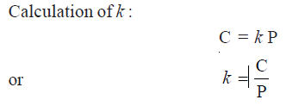
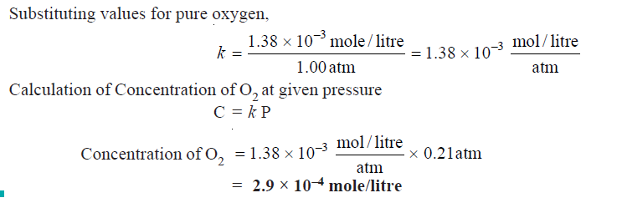
SOLVED PROBLEM 2. At 20° C the solubility of nitrogen gas in water is 0.0150 g/litre when the partial pressure of N2 is 580 torr. Find the solubility of N2 in H2O at 20°C when its partial pressure is 800 torr.

Solubility:

The solubility is defined as the concentration of the solute in solution when it is in equilibrium with the solid substance at a particular temperature. The solubility of a substance is often expressed in terms of number of grams of it that can be dissolved in 100 grams of the solvent.
For example, a saturated solution of sodium chloride in water at 0°C contains 35.7 g of NaCl in 100 g of H2O. That is, the solubility of NaCl in water at 0°C is 35.7 g/100 g. An increase in the temperature generally causes a rise in the solubility. Thus the solubility of copper sulphate in water at 0°C is 14.3 g/100g, while at 100°C it is 75.4 g/100 g.
When a saturated solution prepared at a higher temperature is cooled, it gives a solution which
would contain more solute than the saturated solution at that temperature. Such a solution is called a supersaturated solution. Supersaturated solutions are quite unstable and change to the saturated solution when excess of solute precipitates out.
DETERMINATION OF SOLUBILITY

The solubility of a substance is determined by preparing its saturated solution and then finding
the concentration by evaporation or a suitable chemical method. Saturated solution of a solid substance may be prepared by shaking excess of it with the solvent in a vessel placed in a constant temperature bath and filtering the clear solution. A known volume of this saturated solution is evaporated in a china dish and from the weight of the residue the solubility can easily be calculated. This method though simple, does not yield accurate results. During filtration, cooling would take place and thus some solid may be deposited on the filter paper or in the stem of the funnel. However, this method is quite good for the determination of solubility at room temperature. The evaporation of a liquid is a highly undesirable operation as it is not possible to avoid loss of the liquid caused by spurting. This difficulty can, however, be overcome whenever a chemical method of analysis is available. Another defect in this method is that it takes a long time to establish the equilibrium between the solid and the solution so that the preparation of saturated solution by simple agitation with the solvent is delayed. This difficulty may be overcome by first preparing the saturated solution at a higher temperature and then to cool it to the desired temperature at which solubility is to be determined.

SOLUBILITY CURVES
A curve drawn between solubility and temperature is termed Solubility Curve. It shows the
effect of temperature on the solubility of a substance. The solubility curves of substances like
calcium acetate and calcium chromate show decrease in solubility with increase of temperature while there are others like those of sodium nitrate and lead nitrate which show a considerable increase of solubility with temperature. The solubility curve of sodium chloride shows very little rise with increase of temperature. In general, the solubility curves are of two types :
(1) Continuous solubility curves
(2) Discontinuous solubility curves
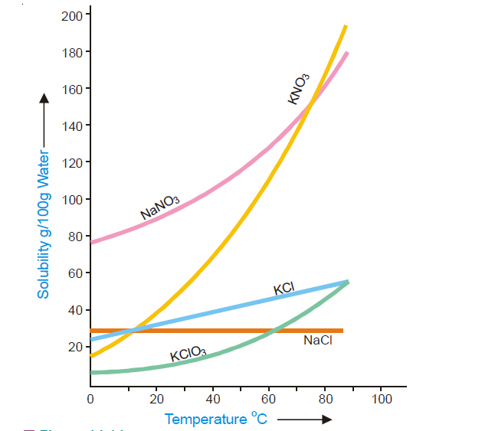
Continuous solubility curves.
Solubility curves of calcium salts of fatty acids, potassium chlorate, lead nitrate and sodium
chloride are Continuous solubility curves as they show no sharp breaks anywhere. In case of
CaSO4.2H2O, no doubt the curve first shows, a rise and then a fall but it remains continuous at the maximum point. Sometimes the solubility curves exhibit sudden changes of direction and these curves are, therefore, called Discontinuous solubility curves. The popular examples of substances which show discontinuous solubility curves are sodium sulphate, calcium chloride, ammonium nitrate etc. In fact, at the break a new solid phase appears and another solubility curve of that new phase begins. The break in a solubility curve thus shows a point where the two different curves meet each other.
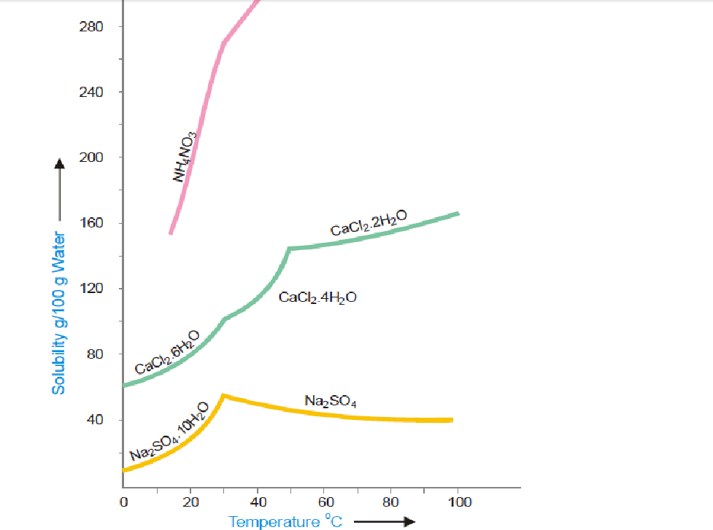
Discontinuous solubility curves.

Problems
SOLVED PROBLEM 1. What is the molarity of a solution prepared by dissolving 75.5 g of pure KOH in 540 ml of solution
SOLVED PROBLEM 2. What weight of HCl is present in 155 ml of a 0.540 M solution?
SOLVED PROBLEM 3. What is the molality of a solution prepared by dissolving 5.0 g of toluene (C7H8) in 225 g of benzene (C6H6) ?
SOLVED PROBLEM 4. 5 g of NaCl is dissolved in 1000 g of water. If the density of the resulting solution is 0.997 g per ml, calculate the molality, molarity, normality and mole fraction of the solute, assuming volume of the solution is equal to that of solvent.

Distribution law and its application: Book-Physical chemistry by Haque & Mollah Page No. 216-222

COLLIGATIVE PROPERTIES: A colligative property may be defined as one which depends on the number of particles in solution and not in any way on the size or chemical nature of the particles.

Dilute solutions containing non-volatile solute exhibit the
following properties :
(1) Lowering of the Vapour Pressure
(2) Elevation of the Boiling Point
(3) Depression of the Freezing Point
(4) Osmotic Pressure

LOWERING OF VAPOUR PRESSURE : RAOULT’S LAW

Relative lowering of Vapour pressure: The vapour pressure of a pure solvent is decreased when a non-volatile solute is dissolved in it. If p is the vapour pressure of the solvent and ps that of the solution, the lowering of vapour pressure is (p – ps). This lowering of vapour pressure relative to the vapour pressure of the pure solvent is termed the Relative lowering of Vapour pressure. Thus,
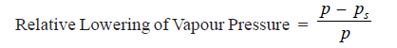

Raoult’s Law: The relative lowering of the vapour pressure of a dilute solution is equal to the mole fraction of the solute present in dilute solution.

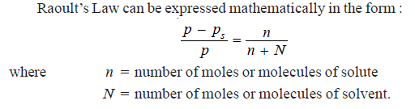
Derivation of Raoult’s Law
The vapour pressure of the pure solvent is caused by the number of molecules evaporating from
its surface. When a nonvolatile solute is dissolved in solution, the presence of solute molecules in the surface blocks a fraction of the surface where no evaporation can take place.
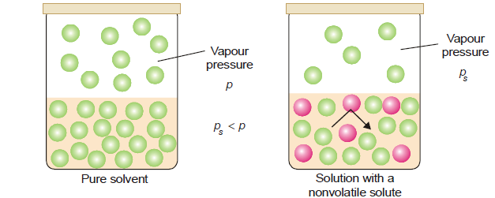
This causes the lowering of the vapour pressure. The vapour pressure of the solution is, therefore, determined by the number of molecules of the solvent present at any time in the surface which is proportional to the mole fraction.
That is,
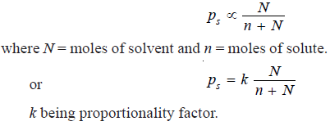
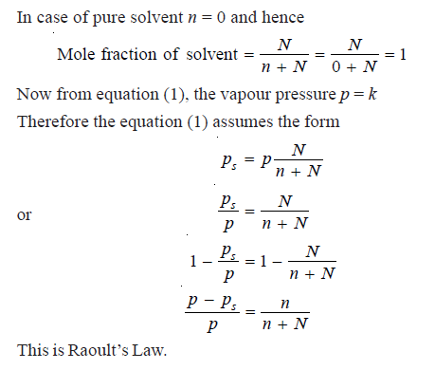
SOLVED PROBLEM. Calculate the vapour pressure lowering caused by the addition of 100 g of sucrose (mol mass = 342) to 1000 g of water if the vapour pressure of pure water at 25°C is 23.8 mm Hg.

ELEVATION OF BOILING POINT: When a liquid is heated, its vapour pressure rises and when it equals the atmospheric pressure, the liquid boils. The addition of a non volatile solute lowers the vapour pressure and consequently elevates the boiling point as the solution has to be heated to a higher temperature to make its vapour pressure become equal to atmospheric pressure. If T_{b} is the boiling point of the solvent and T is the boiling point of the solution, the difference in the boiling points (ΔT) is called the elevation of boiling point.
T – T_{b} = ΔT

FREEZING–POINT DEPRESSION: The vapour pressure of a pure liquid changes with temperature as shown by the curve ABC, in Fig. There is a sharp break at B where, in fact, the freezing-point curve commences. Thus the point B corresponds to the freezing point of pure solvent, T_{f}. The vapour pressure curve of a solution (solution 1) of a nonvolatile solute in the same solvent is also shown in Fig. It is similar to the vapour pressure curve of the pure solvent and meets the freezing point curve at F, indicating that T₁ is the freezing point of the solution. The difference of the freezing point of the pure solvent and the solution is referred to as the Depression of freezing point. It is represented by the symbol ΔT or ΔT_{f} .
T_{f} – T₁ = Δ T

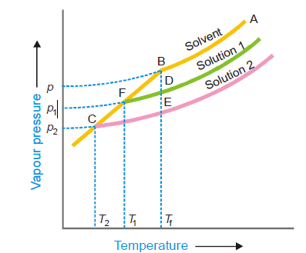
OSMOTIC PRESSURE: The hydrostatic pressure built up on the solution which just stops the osmosis of pure solvent into the solution through a semipermeable membrane, is called Osmotic Pressure.

From a study of the experimental results obtained by Pfeffer, van’t Hoff showed that for dilute
solutions :
(a) The osmotic pressure of a solution at a given temperature is directly proportional to its
concentration.
(b) The osmotic pressure of a solution of a given concentration is directly proportional to the
absolute temperature.

DISTRIBUTION LAW
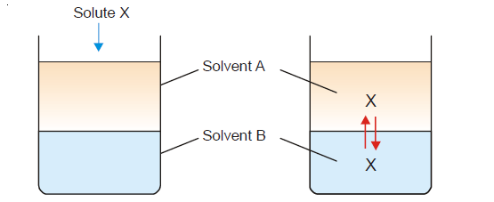

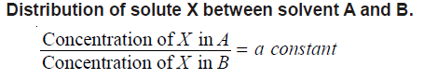

STATEMENT OF NERNST’S DISTRIBUTION LAW:

If a solute X distributes itself between two immiscible solvents A and B at constant temperatureand X is in the same molecular condition in both solvents,

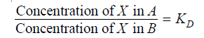
If C₁ denotes the concentration of the solute in solvent A and C₂ the concentration in solvent B, Nernst’s Distribution law can be expressed as

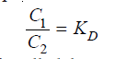
The constant K_{D} (or simply K) is called the Distribution coefficient or Partition coefficient or Distribution ratio.

SOLVED PROBLEM 1. A solid X is added to a mixture of benzene and water. After shaking well and allowing to stand, 10 ml of the benzene layer was found to contain 0.13 g of X and 100 ml of water layer contained 0.22 g of X. Calculate the value of distribution coefficient.

SOLUTION
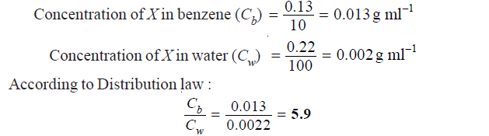
LIMITATIONS OF DISTRIBUTION LAW
The conditions to be satisfied for the application of the Nernst’s Distribution law are
1. Constant temperature. The temperature is kept constant throughout the experiment.
2. Same molecular state. The molecular state of the solute is the same in the two solvents. The
law does not hold if there is association or dissociation of the solute in one of the solvents.
3. Equilibrium concentrations. The concentrations of the solute are noted after the equilibrium has been established.
4. Dilute solutions. The concentration of the solute in the two solvents is low. The law does
not hold when the concentrations are high.
5. Non-miscibility of solvents. The two solvents are non-miscible or only slightly soluble in
each other. The extent of mutual solubility of the solvents remains unaltered by the addition
of solute to them.

APPLICATIONS OF DISTRIBUTION LAW
There are numerous applications of distribution law in the laboratory as well as in industry. Here we will discuss some more important ones by way of recapitulation.
(1) Solvent Extraction
This is the process used for the separation of organic substances from aqueous solutions. The
aqueous solution is shaken with an immiscible organic solvent such as ether (or benzene) in a
separatory funnel. The distribution ratio being in favour of ether, most of the organic substance
passes into the ethereal layer. The ethereal layer is separated and ether distilled off. Organic substance is left behind.
(2) Partition Chromatography
This is a modern technique of separating a mixture of small amounts of organic materials. A paste of the mixture is applied at the top of a column of silica soaked in water. Another immiscible solvent, say hexane, is allowed to flow down the column. Each component of the mixture is partitioned between the stationary liquid phase (water) and the mobile liquid phase (hexane). The various components of the mixture are extracted by hexane in order of their distribution coefficients. Thus the component with the highest distribution coefficient is first to move down in the flowing hexane which is collected separately. Similarly, a component with a lower distribution ratio comes down later and is received in another vessel.
(3) Desilverization of Lead (Parke’s Process)
When molten zinc is added to molten lead containing silver (argentiferous lead), zinc and lead form immiscible layers and silver is distributed between them. Since the distribution ratio is about 300in favour of zinc at 800º C, most of silver passes into the zinc layer. On cooling the zinc layer, an alloy of silver and zinc separates. The Ag-Zn alloy is distilled in a retort when zinc passes over leaving silver behind. The lead layer still contains unextracted silver. This is treated with fresh quantities of molten zinc to recover most of the silver.
(4) Confirmatory Test for Bromide and Iodide
The salt solution is treated with chlorine water. Small quantity of bromine or iodine is thus
liberated. The solution is then shaken with trichloromethane (chloroform). On standing chloroform forms the lower layer. The free bromine or iodine being more soluble in chloroform concentrates into the lower layer, making it red for bromine and violet for iodine.

(5) Determination of Association
When a substance is associated (or polymerized) in solvent A and exists as simple molecules in solvent B, the Distribution law is modified as
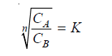
when n is the number of molecules which combine to form an associated molecule.
(6) Determination of Dissociation
Suppose a substance X is dissociated in aqueous layer and exists as single molecules in ether.
If x is the degree of dissociation (or ionisation), the distribution law is modified as
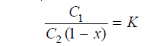
where C₁ = concentration of X in benzene
C₂ = concentration of X in aqueous layer
The value of x can be determined from conductivity measurements, while C₁ and C₂ are found
experimentally. Thus the value of K can be calculated. Using this value of K, the value of x for any other concentrations of X can be determined.
(7) Determination of Solubility
Suppose the solubility of iodine in benzene is to be determined. Iodine is shaken with water and benzene. At equilibrium concentrations of iodine in benzene (C_{b}) and water (C_{w}) are found
experimentally and the value of distribution coefficient calculated.
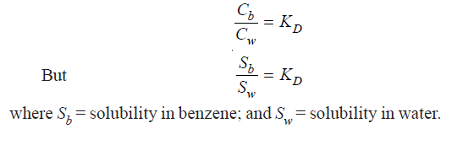
(8) Deducing the Formula of a Complex Ion (I₃⁻)
Some iodine is added to a solution of KI and the reaction mixture shaken with benzene.
(a) The [I₂] in water layer can be found knowing the value of K_{D} (determined separately) and
concentration of iodine in benzene (determined by titration against thiosulphate).
(b) The total concentration of iodine, [I₂] + [I₃⁻] in water layer is found by titration against
thiosulphate. Knowing [I₂] from (a), [I₃⁻ ] can be calculated.
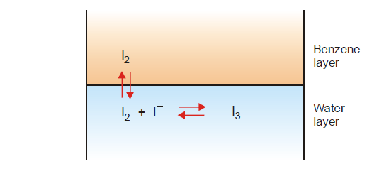
(c) The initial concentration of KI taken is represented by the equilibrium concentrations
[I–] + [I₃⁻ ]. Knowing [I₃⁻] from (b), [I–] can be found. Substituting the above values of concentrations in the law of Mass Action equation of the reaction in water layer,
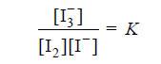
the value of equilibrium constant K can be calculated. If it comes out to be constant for different
concentrations of iodine, it stands confirmed that the formula of the complex I₃⁻ , which we assumed is correct.
(9) Distribution Indicators
In iodine titrations, the end point is indicated by adding starch suspension which turns blue. A
greater sensitivity can be obtained by using what we may call ‘Distribution Indicator’. A few drops of an immiscible organic solvent such as chloroform (or carbons tetrachloride) is added to the solution. The bulk of any iodine present passes into the organic layer and imparts intense violet colour to it.

